**Web server and App server Task**

**1)** Install nginx and run nginx on port number 81

* I Lauched one instance for nginx

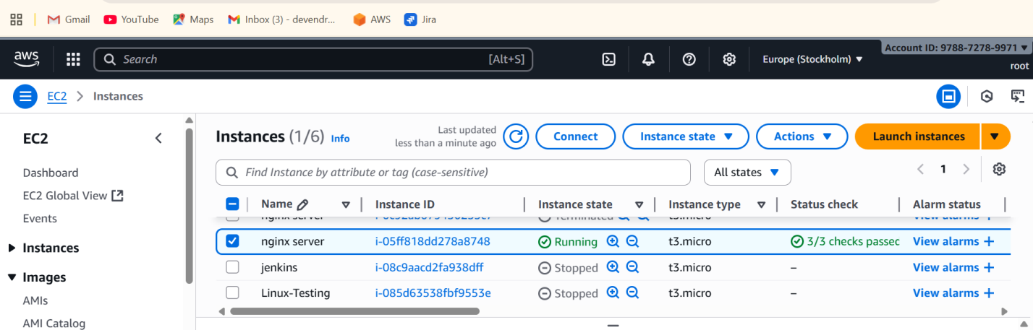

* Connect to the remote machine by using  **ssh –i nginx-testing .pem** [**ec2-user@13.60.81.231**](mailto:ec2-user@13.60.81.231)

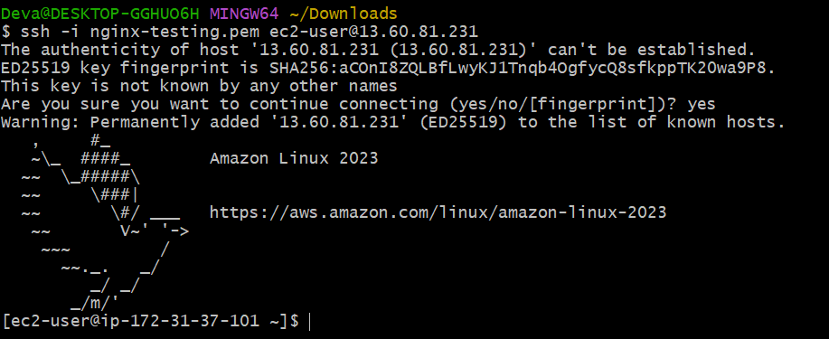

* Switch to ec2 user to root user by using **sudo su –**

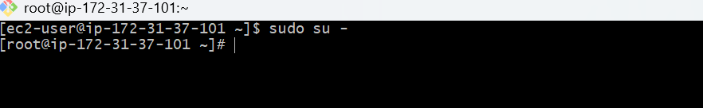

* Installed nginx - **yum install nginx**

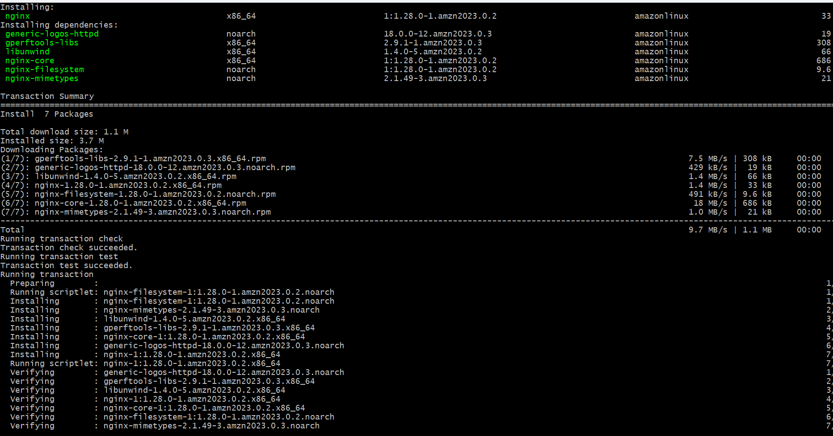

* Checking the status nginx - **systemctl status nginx**
* it is in in active



* sy**stemctl start nginx** – start the nginx
* systemctl status nginx - check the status
* it shows active

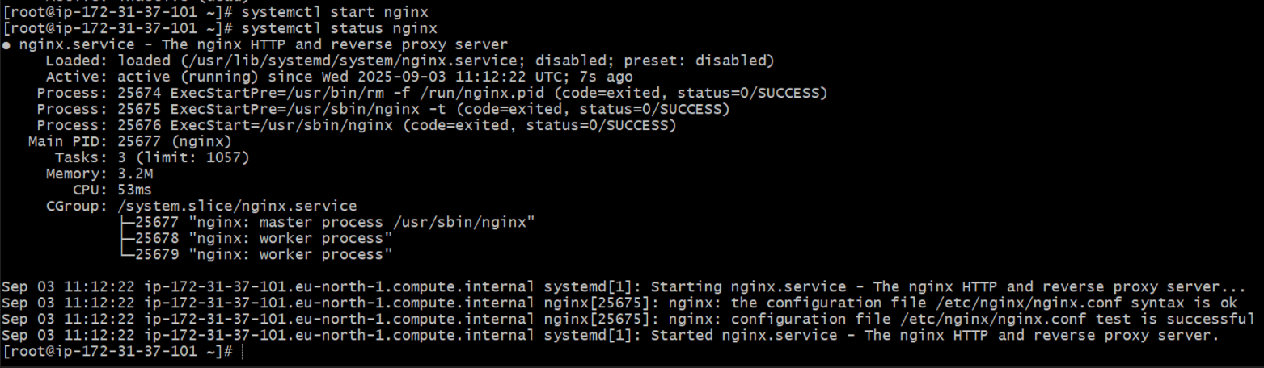

* **netstat –na | grep 80** - Check the port number is running or not
* **lsof –i tcp:80** - It shows the running services in that port number
* **ps –ef | grep nginx** - It shows running process of nginx

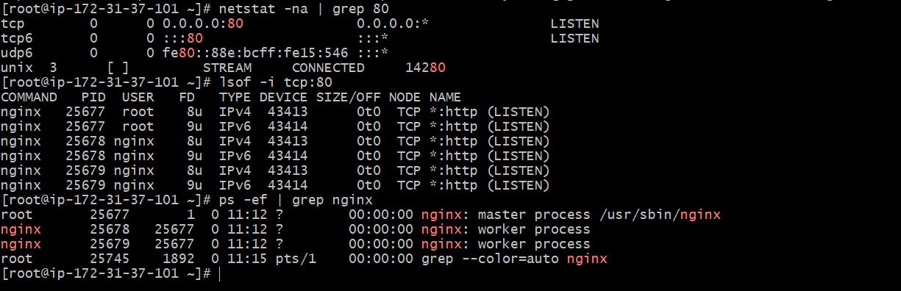

* And also check in browser by using ip address and port number 80



* Make configuration changes ,use find command - **find / -name nginx.conf**
* And create backup file **cd /etc/nginx**
* **ls**  - list of files
* Copy that file to some other location - **cp nginx.conf nginx.conf.backup**

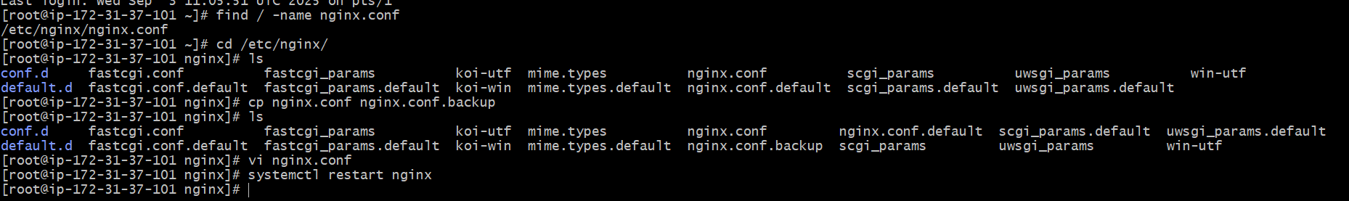

* **Cat nginx.conf.backup -** copy all the content manually
* Open **vi nginx.conf**  and paste the content and change the port number 80 to 81
* It listens **81**
* And restart the nginx **systemctl restart nginx**
* And cross check in browser with port number 81 is working or not
* It shows nginx test page

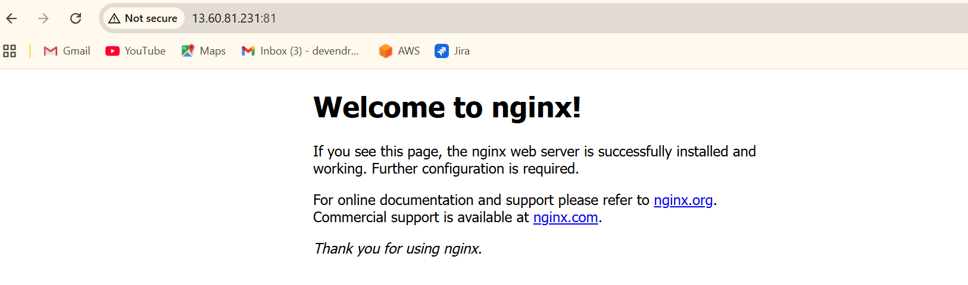

* And also check in browser with port number 80 , it shows (**this site can’t be reached**)
* It won’t works , Because you change the port number 80 to 81

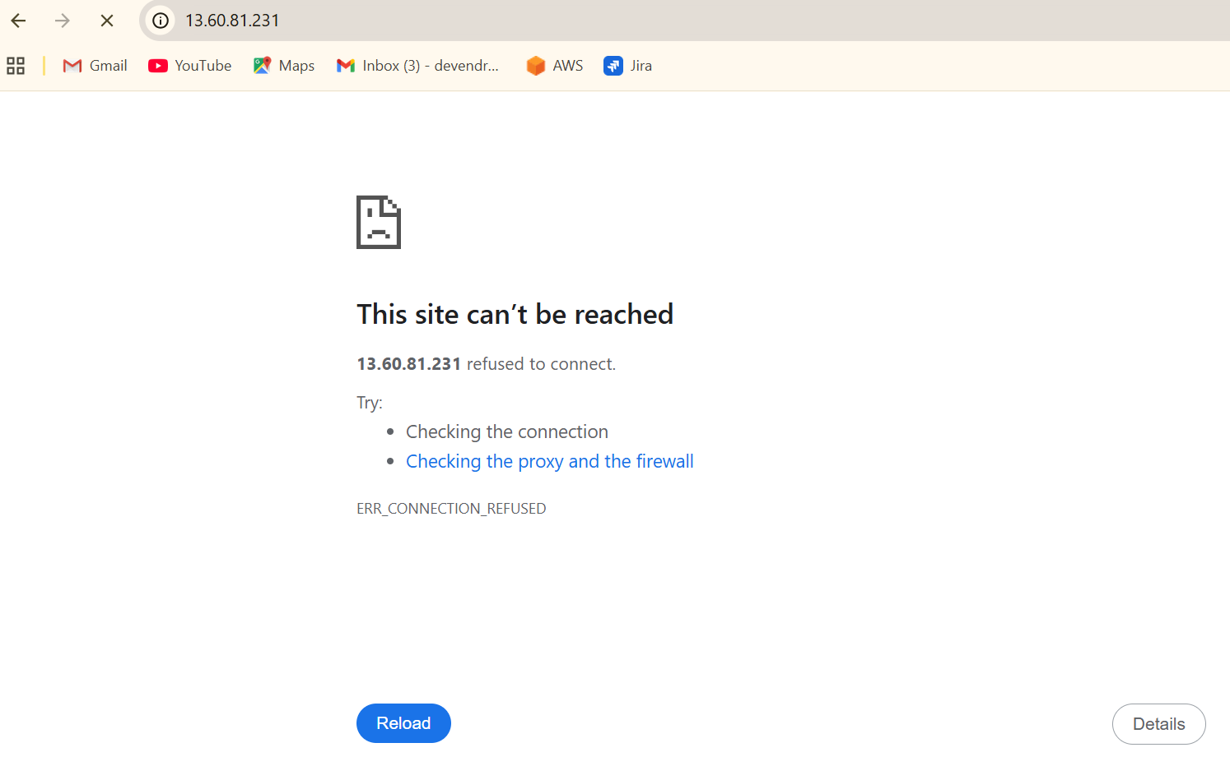

**2)** If you want to customize your own nginx test page

* **/usr/share/nginx/html -** Default deployment location for nginx
* **Cd /usr/share/nginx/html**



* **ls -**  It shows the files
* **cat index.html -** It shows the nginx test page

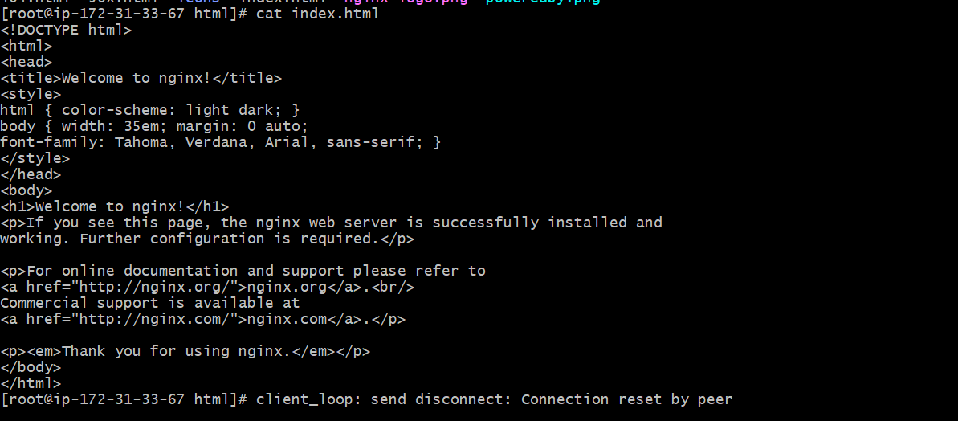

* **vi index.html -** You enter to edit the nginx test page and edit **Welcome to Techie Horizon Deva**

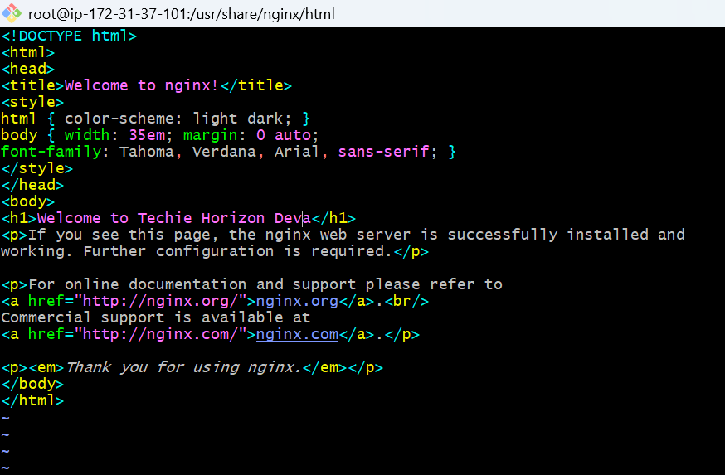

* **:wq! -** Saved the content
* And check in browser the test page is updated or not with port number 81



**3) Install Apache and run Apache on port number 82.**

* **Yum install httpd –** install the httpd package

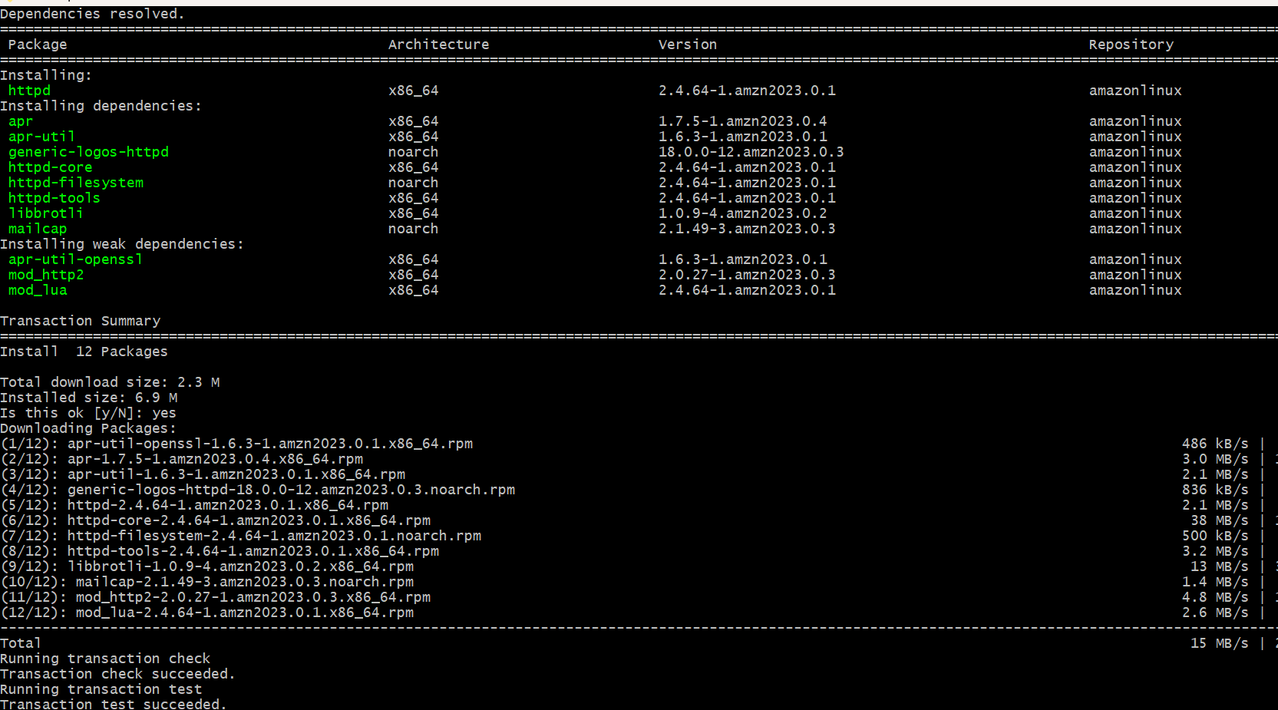

* **Systemctl status httpd -** it shows the status of that httpd like (active or in active)
* **Systemctl start httpd -**  start the httpd
* Again check the status its active or inactive - **systemctl status httpd**

**net**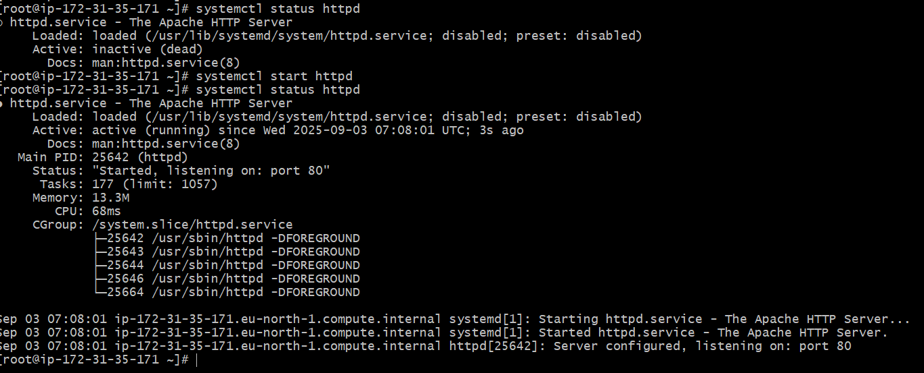

* **netstat –na | grep 80 -** see the port number is running or not
* **lsof –i tcp:80 -**it shows httpd is running
* **ps –ef | grep httpd -** Here we can see the services related to httpd

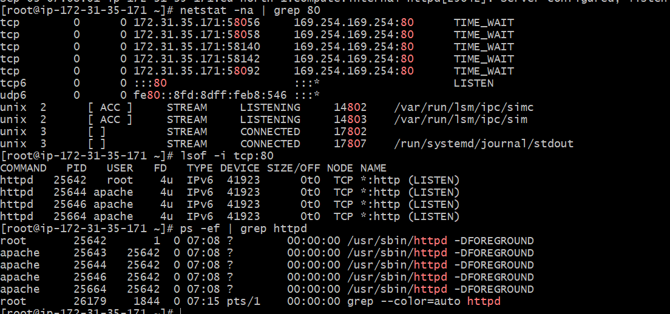

* Now I want to access this in browser
* You just copy the public ip and paste it in the browser and give **:80** port number
* Now we can see the one testpage in browser



* Test page is available then it means ,our service is successfully running .
* Change the directory to **cd /etc/httpd/conf**
* **ls -** it gives list of files
* Copy that file to some another location - **cp httpd.conf /opt/**
* Rename the file to  **mv httpd.conf httpd.conf.backup**
* **ll -**  it gives long list

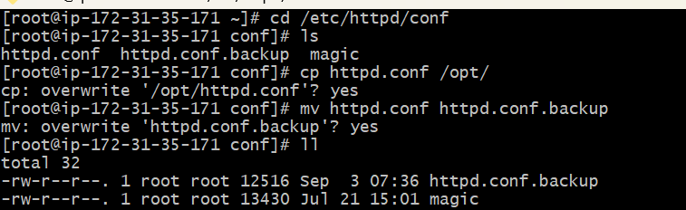

* **cat httpd.conf.backup -**  it gives the content of httpd application

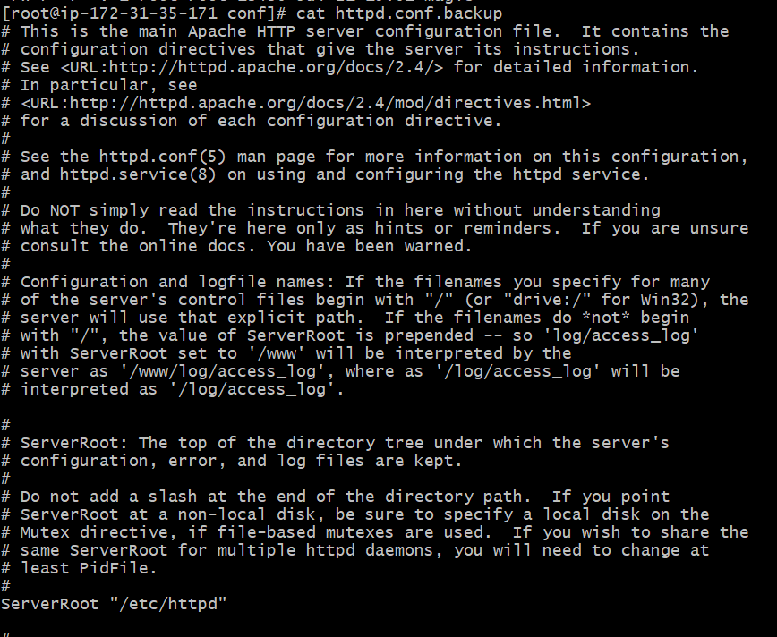

* And I will create one more file **vi httpd.conf**



* Paste the content and make port number 80 to 82
* Listen 82

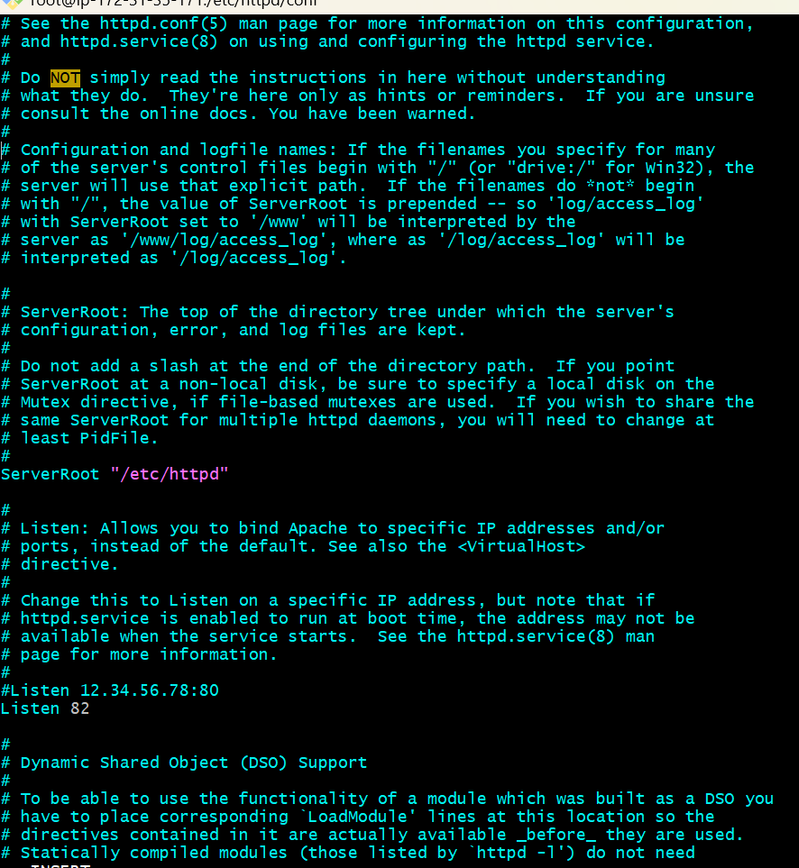

* And restart the system – **systemctl restart httpd**
* **Systemctl status httpd -** It shows the status of httpd
* And you cross check in browser with port number **82 (**it shows the httpd test page**)**



* And also you check the port number **80**
* It shows no page found (This site can’t be reached)

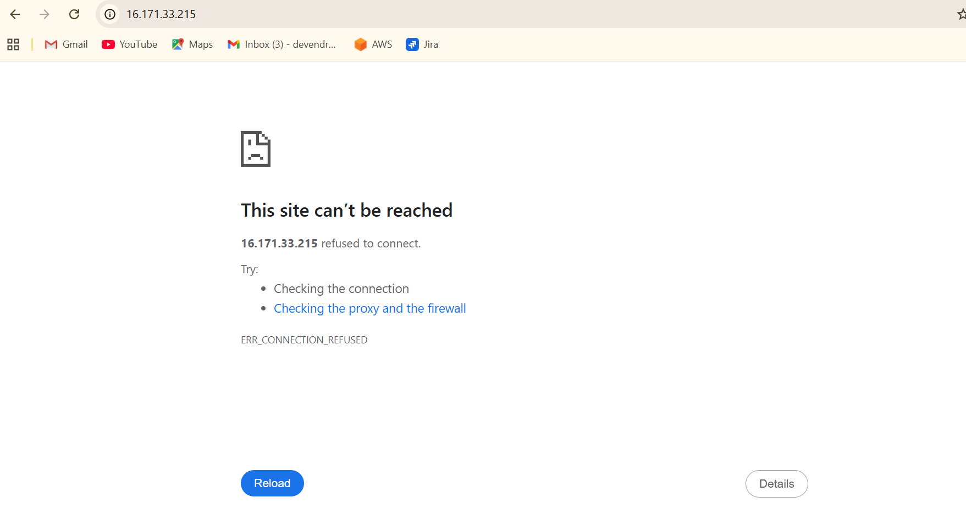

* If you want to customize your own apache test page
* Default location  **cd /var/www/html**
* **ll -** Long list
* Create a file **index.html**

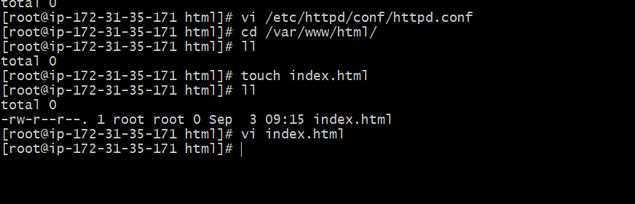

* **Vi index.html -** write the content in that file (**Welcome to techie horizon**)



* Save **- esc+ :wq!**
* And go to browser and refresh,it shows



* And check with port number 80 it wont works



5) Install Apache tomcat on port number 8082

* Go to google and search apache tomcat

|

Open apache tomcat site

|

And select which version you want to download

|

When you select version,it shows binary distributions

|

In binary distributions,have core field , in that core field ,we have different files

|

You just go to **tar.gz(pgp,sha512)**  and give right click and copy the link



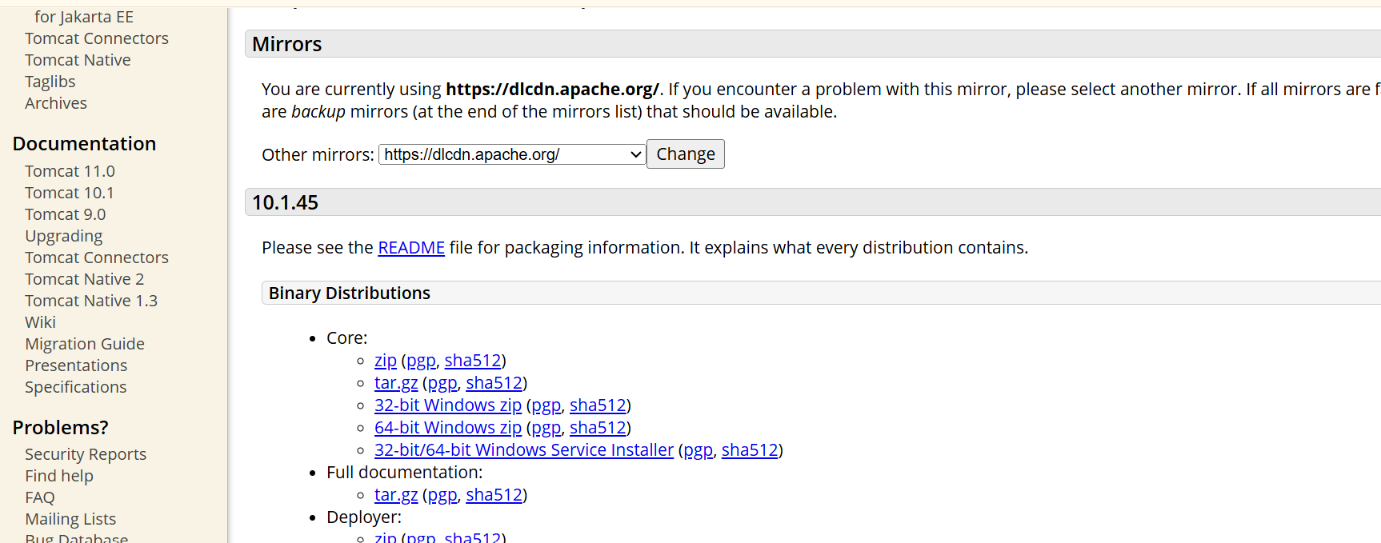

* Open gitbash and
* **Cd /opt/ -** This is the optional directory
* **Wget link -** copy the link from web browser and install it

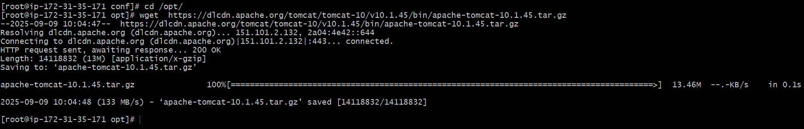

* **ls -** It shows the list of files

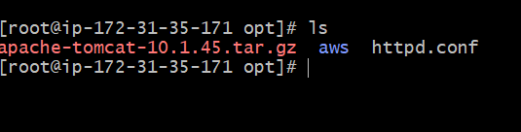

* **tar xvf apache-tomcat-10.1.45.tar.gz -** To extract the file

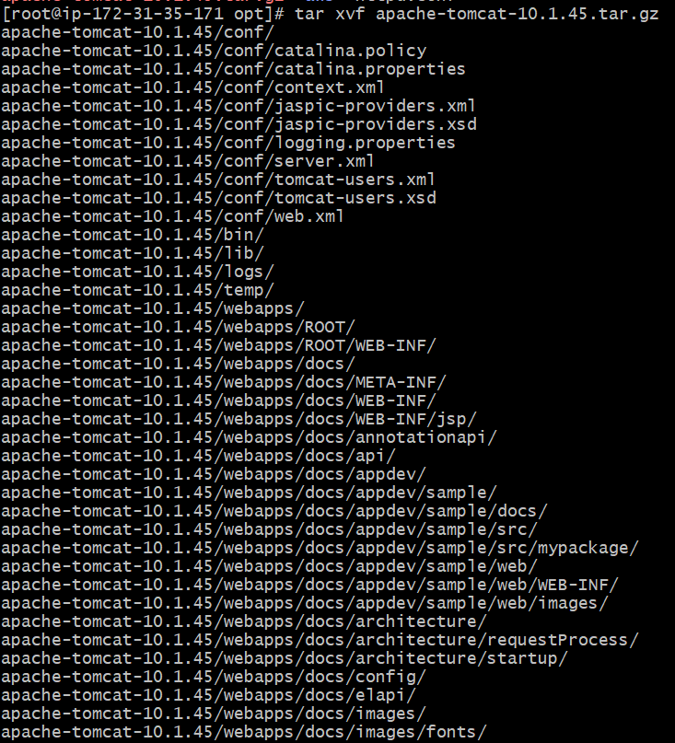

* **Ls -** It gives list



* Change the directory to apache –tomcat-9.0.80 - **cd apache –tomcat -9.0.80**
* **pwd -** Present working directory

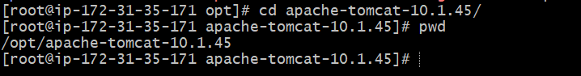

* **ls -** It will shows all configurations and files related to your tomcat



* **cd bin/ -** Change directory to bin
* **ls -** It shows the list of files



* yum install java - Installed java

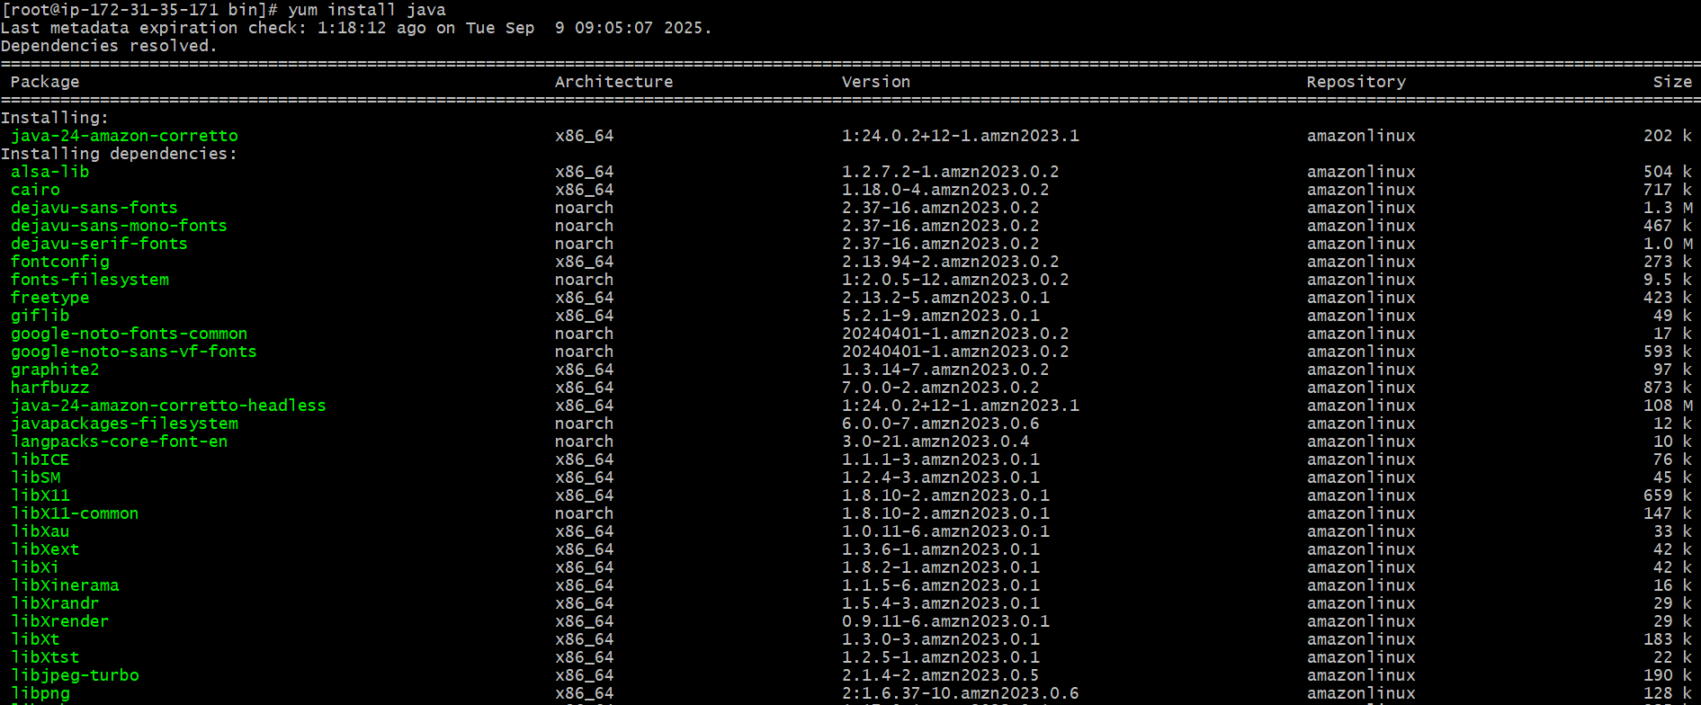

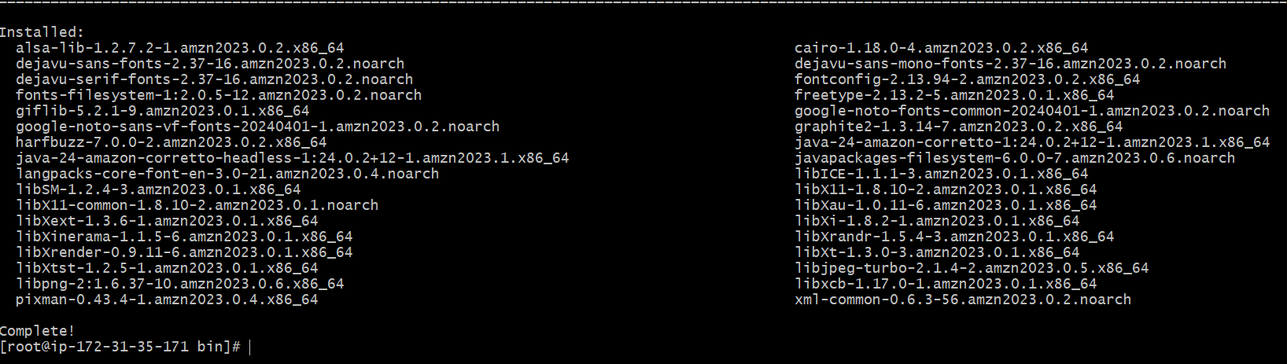

* **ps –ef | grep tomcat -** To check the running process of tomcat
* **netstat –na | grep 8080 -**  Check the port is running

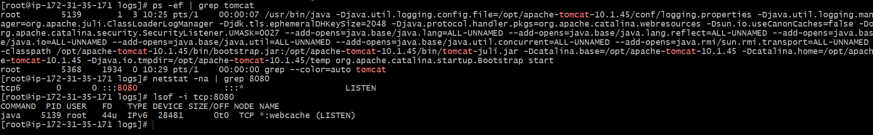

* **bash startup.sh -** Tomcat started

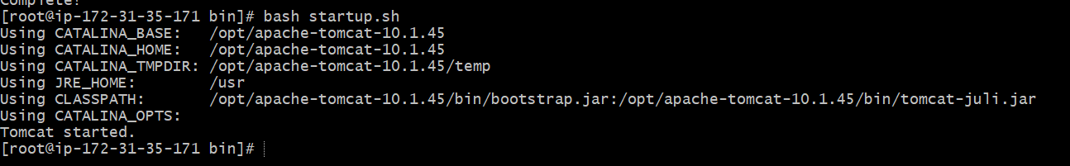

* Check in the browser using public ip and with port number 8080

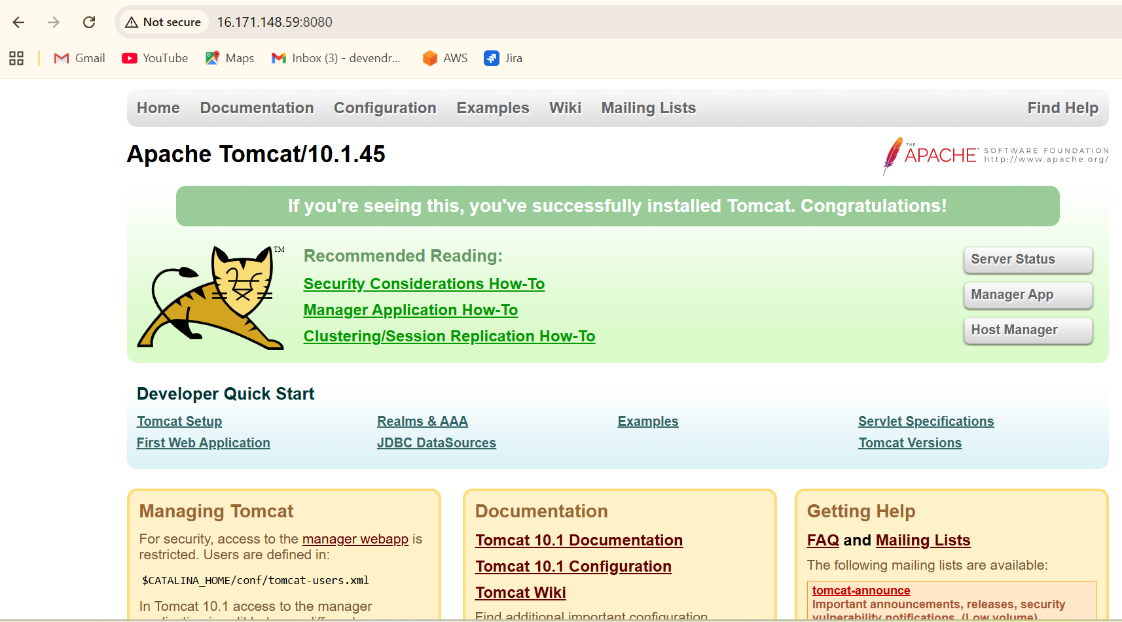

* **Cd .. -**  one step back
* **Cd conf -** change directory to conf
* **ls -** List of files

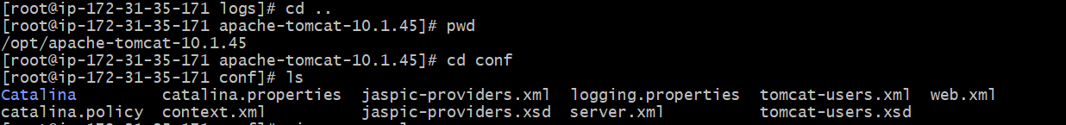

* **vi server.xml -**  To edit the content and change the port number to 8082



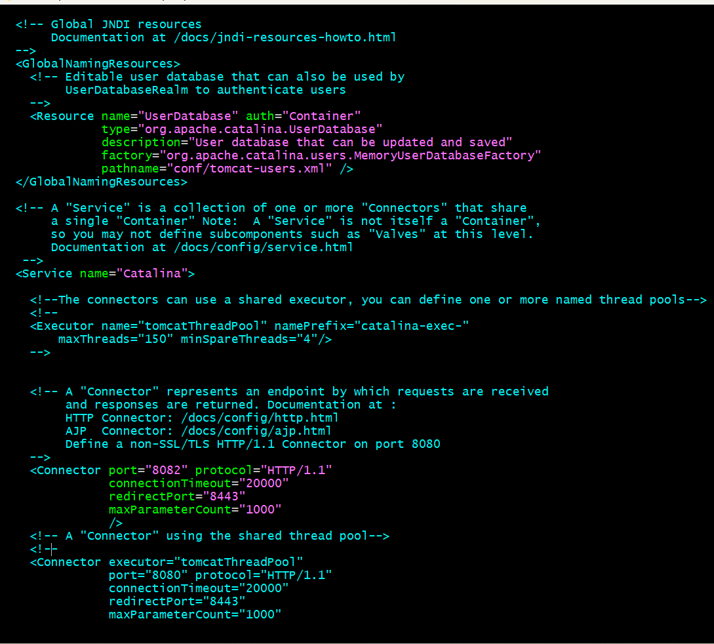

* **cd .. –** One step back
* **ls** - It gives list of files and directories
* And change directory to **cd bin/**



* **Ls -** List of files



* **bash shutdown.sh -** Shutdown the tomcat

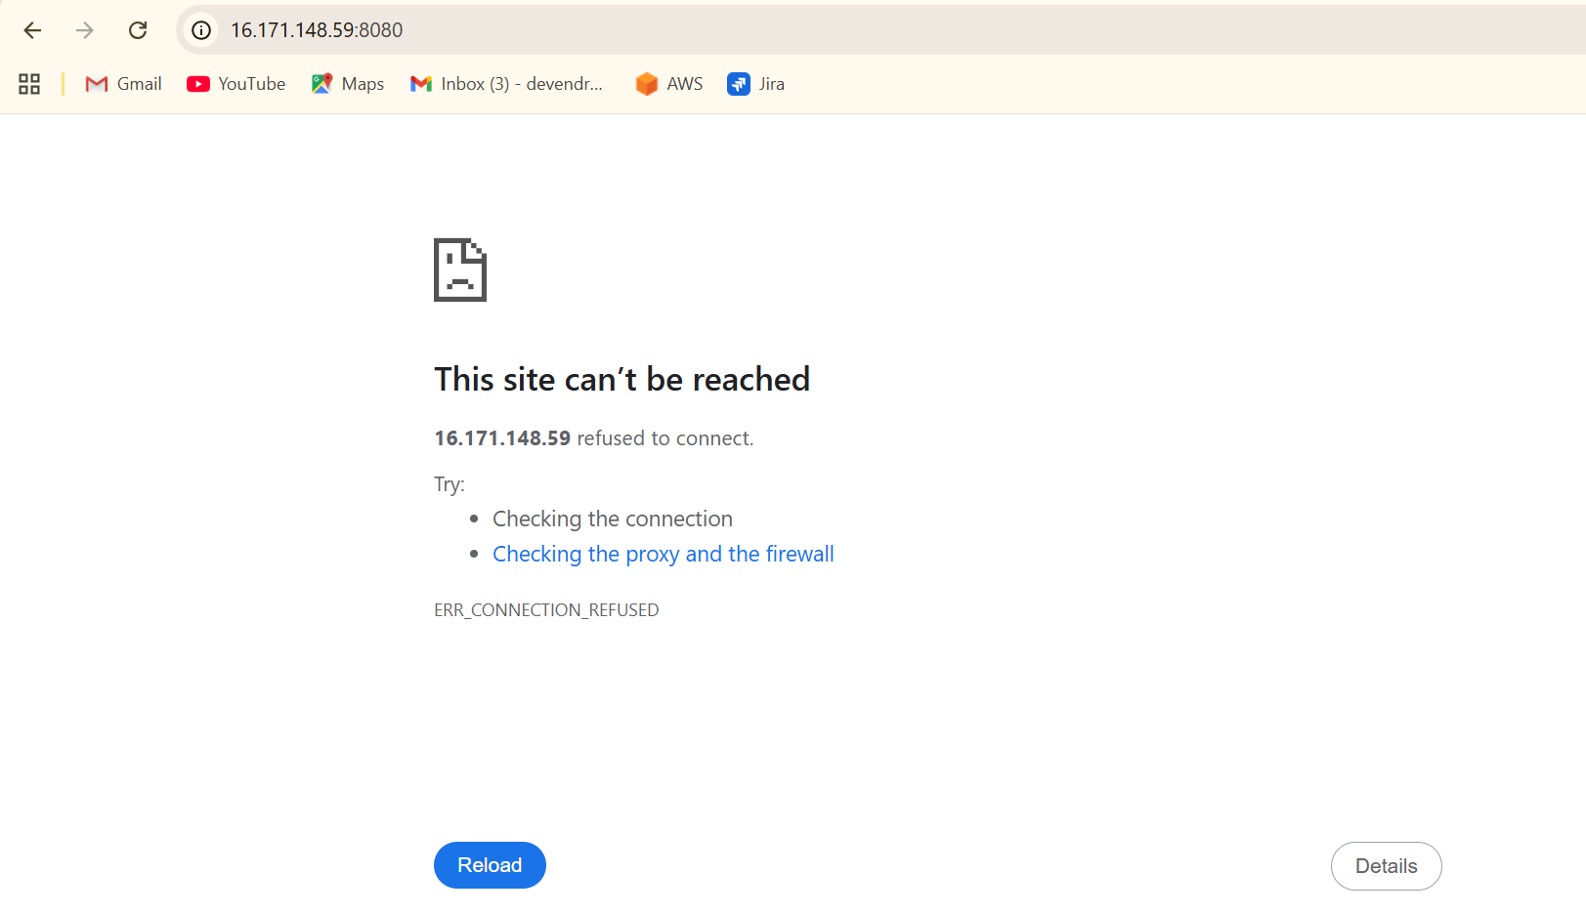

* **bash ./startup.sh -** Start the tomcat and give port number 8082

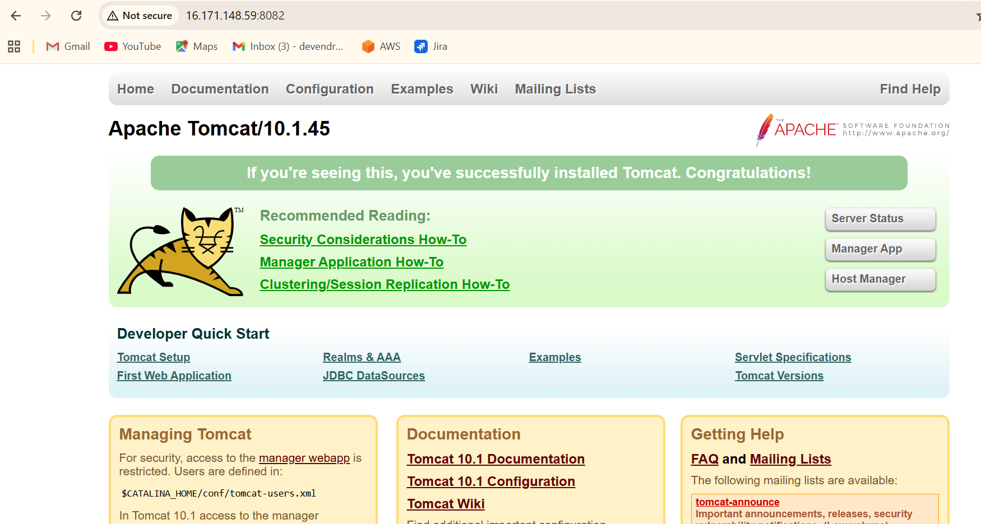

**6) Deploy a sample app on webapps**

* **cd .. –** One step back
* **ls -** List of files



* **cd webapps -** Change the directory to webapps



* Go to google and search sample.war



* Tap on sample application

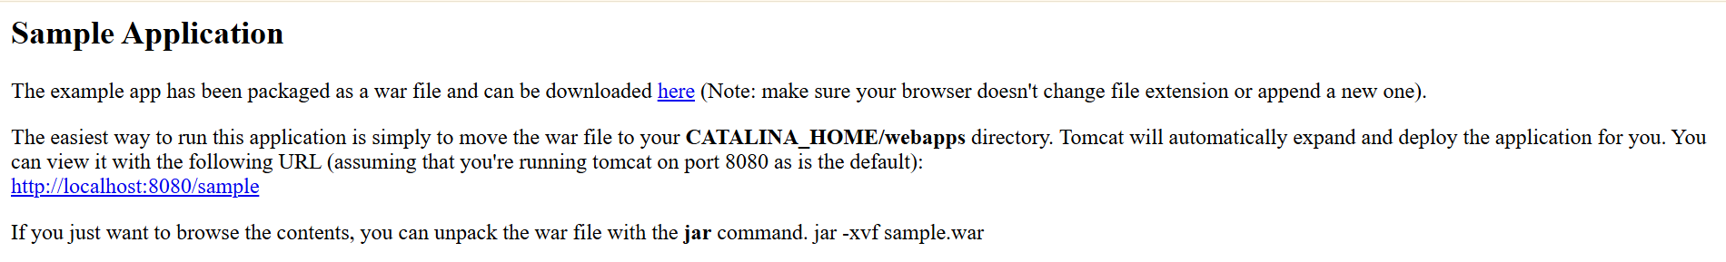

* And **here** give right click and copy the link and paste it in gitbash
* **Wget link**  - to download the sample war

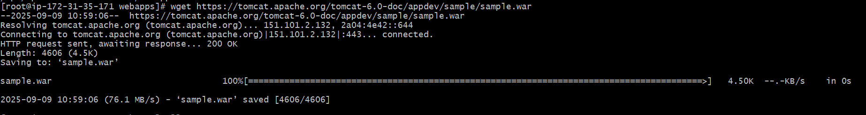

* **ll -** It gives long list

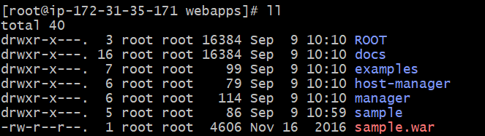

* Go to google and check the public ip with port number 8082

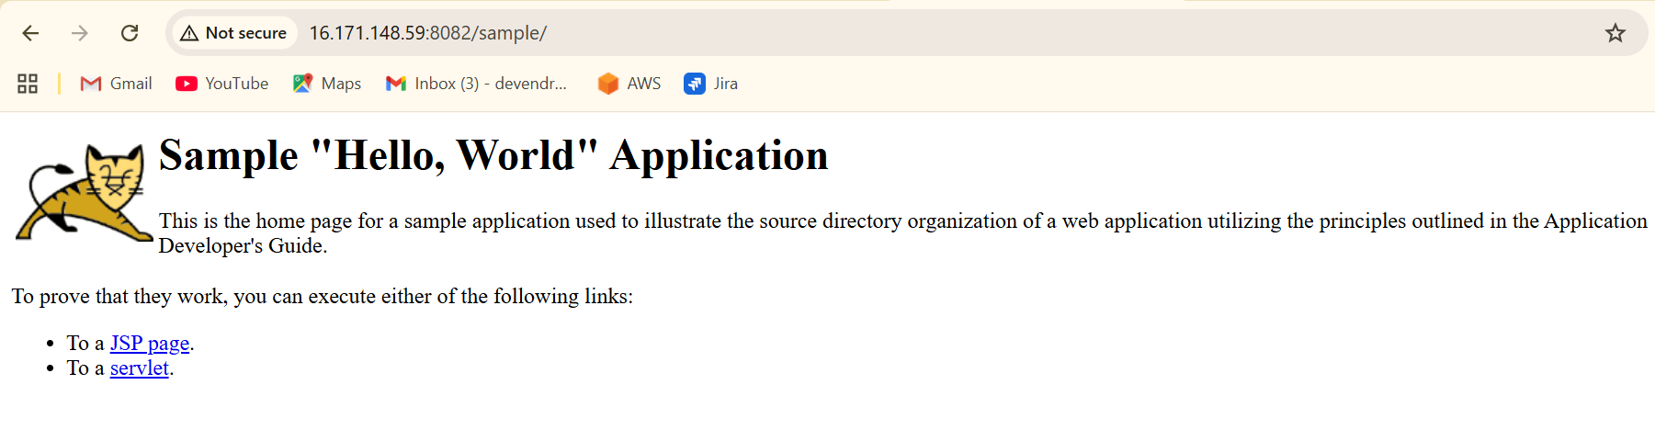

**7)create a tomcat.service file for tomcat**

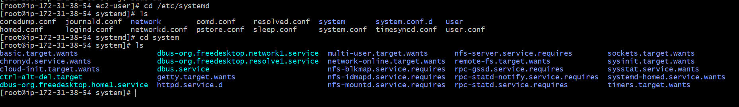

* Go to default location of file that is sysyem
* Add tomcat.service file : **vi tomcat.service**
* Add configuration:

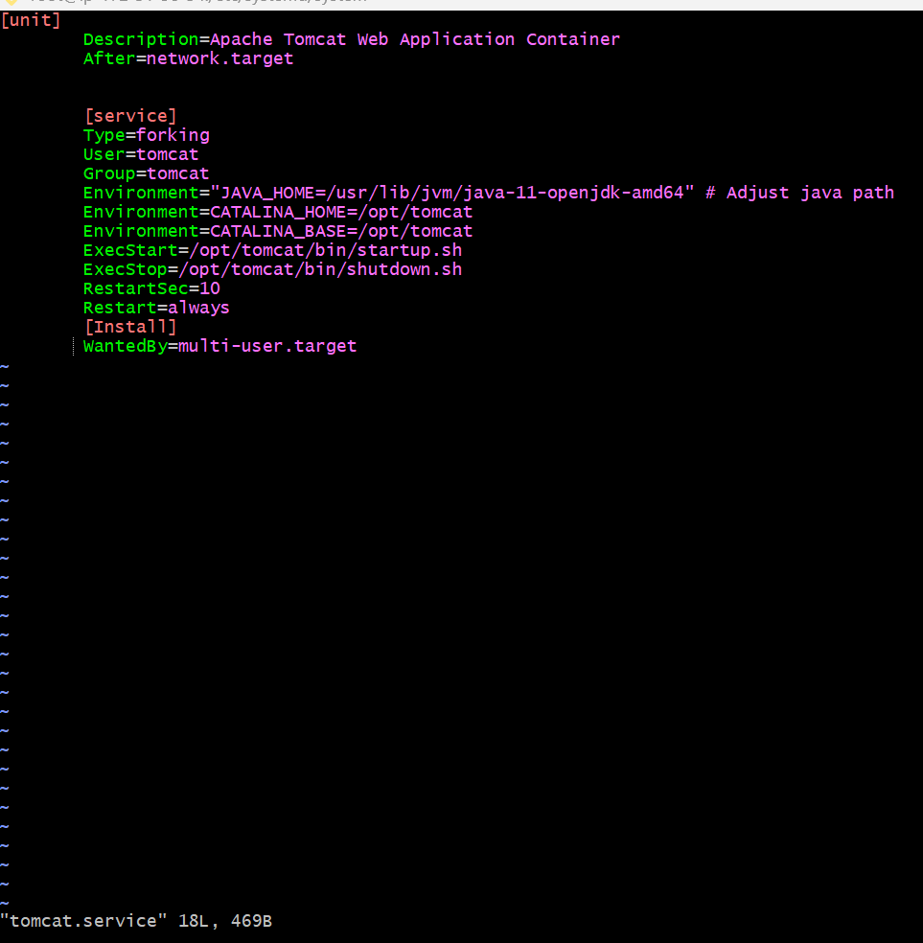

* Save and exit
* Restart the service
* Make sure to create user with name tomcat and give access
* Reload the daemon

**8) Configure HA Proxy server**

* Launch 3 ec2 instances name as server-1, server-2, and HAproxy

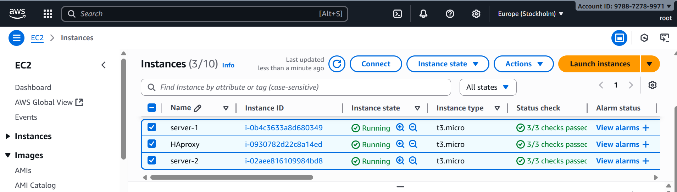

Run the following command to access the server-1

* Ssh –i key.pem ec2-user@public ip address of server-1 instance

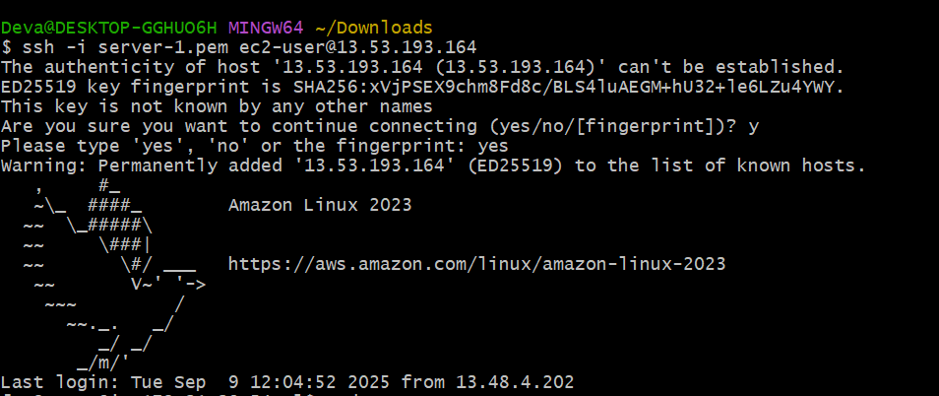

* Switch to root user – **sudo su –**

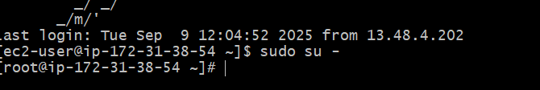

* **Yum update –y**

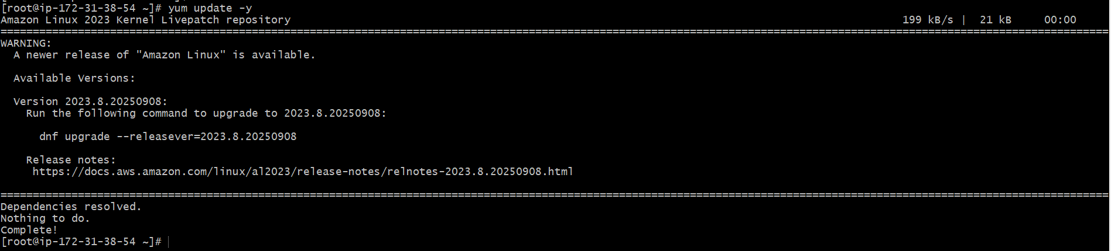

* **Yum install httpd –y**

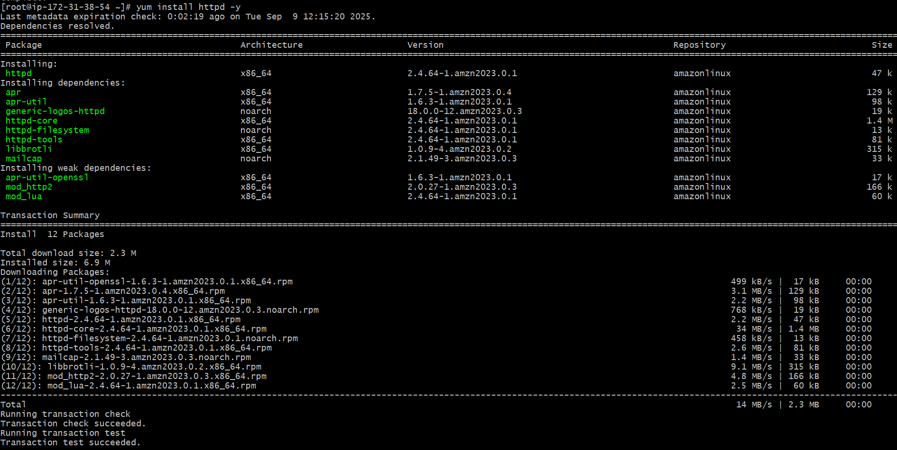

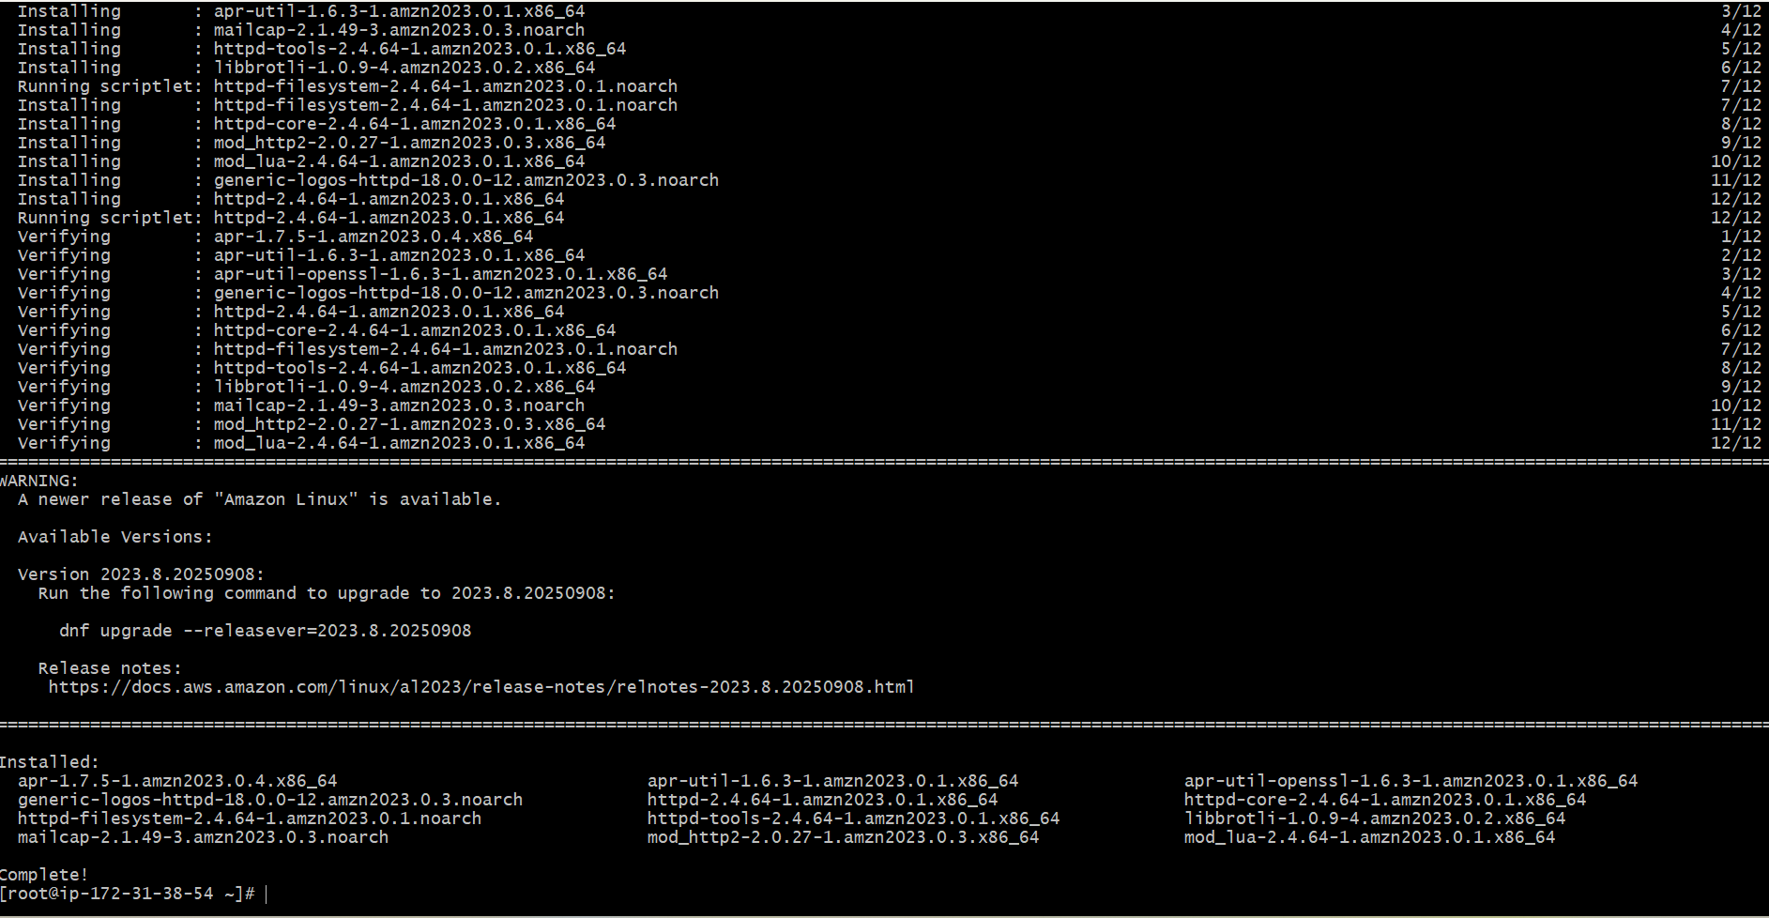

* **Vi /etc/hosts**
* Add HAproxy server public ip address

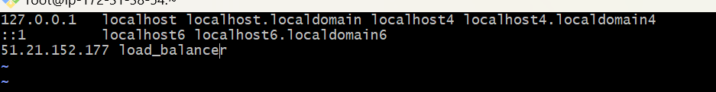

* **Cat /etc/hosts -** It shows the content of file

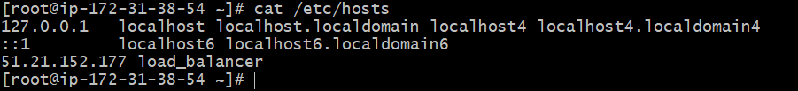

Run below command on server-1

* Ping load_balancer –c 4

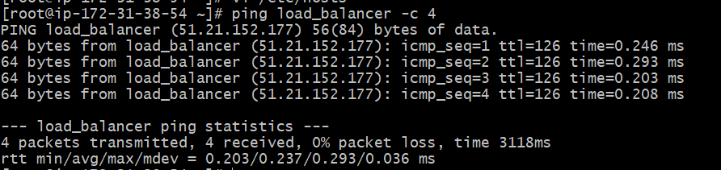

* **Systemctl start httpd**
* **Systemctl status httpd**

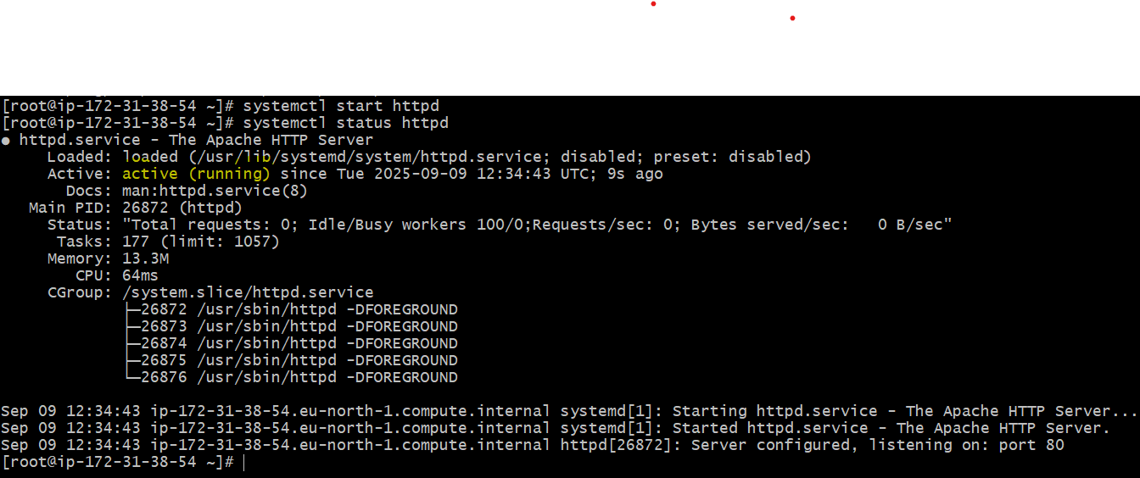

* Check in browser with server-1 public ip address and port number 80



**Server-2 Steps:**

Run the following command to access server-2

* Ssh –I key.pem ec2-user@public ip address of server-2 instance

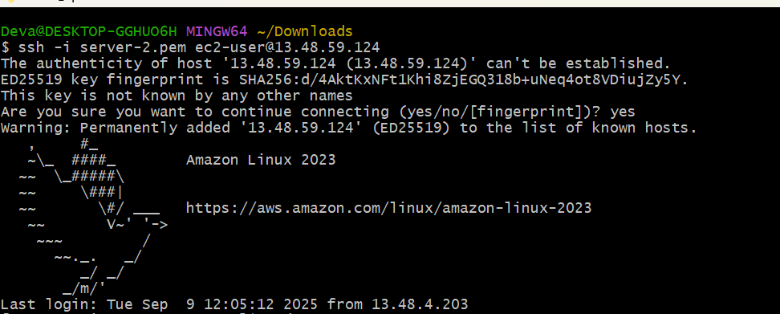

* Switch to root user- **sudo su –**

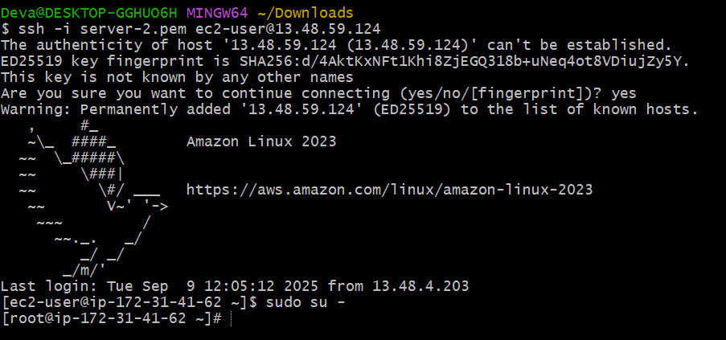

* Yum update –y

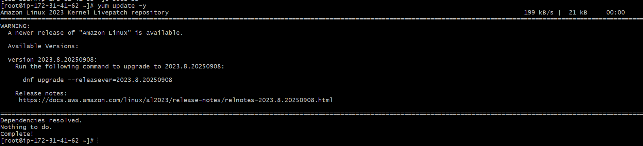

* **Yum install nginx –y**
* Sudo amazon-linux-extras install nginx1 –y

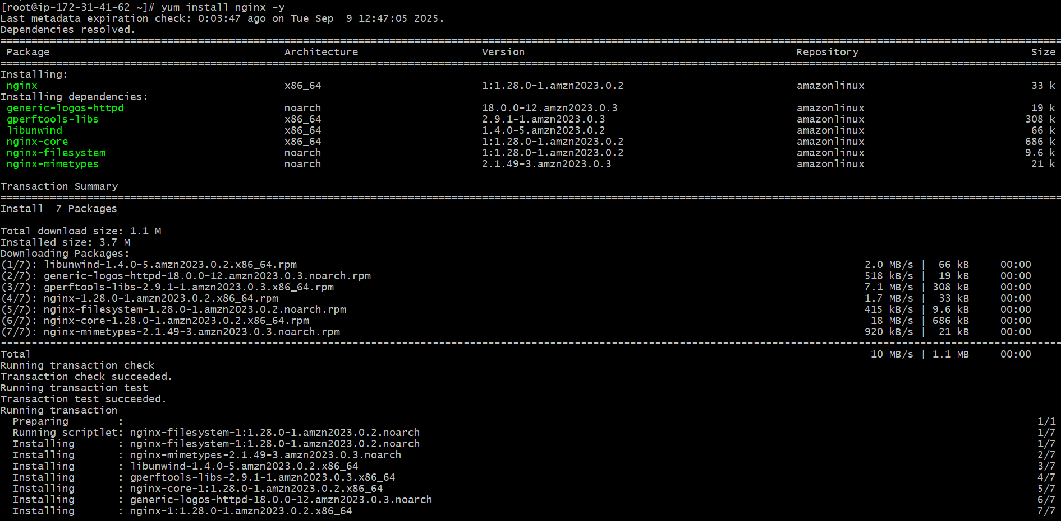

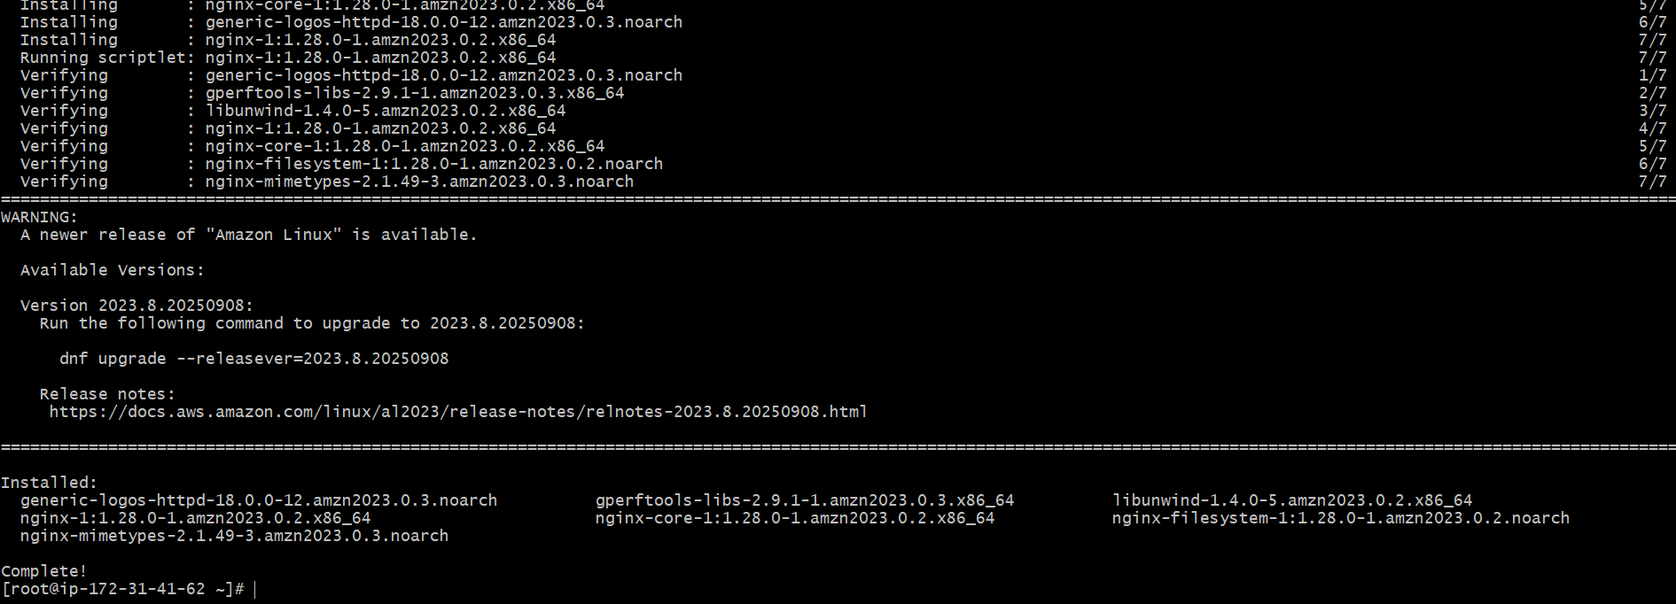

* **Vi /etc/hosts**
* Add HAproxy server public ip address

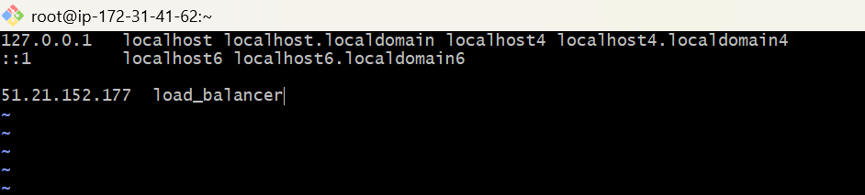

* **Cat /etc/hosts -**read the contents of file

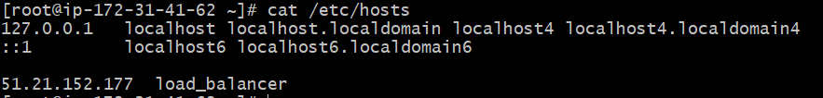

Run below command on server-2

* **Ping load-balancer –c 4**

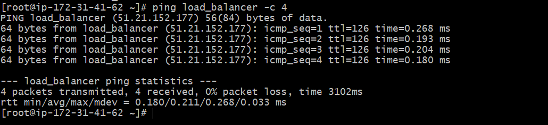

* **Systemctl start nginx**
* **Systemctl status nginx**

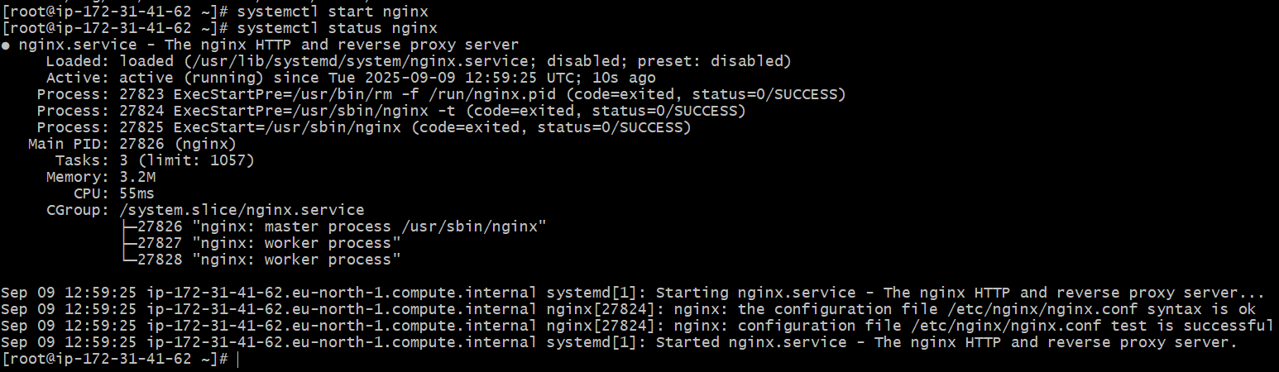

* Check in browser with server-2 public ip address and port number 80



**HAproxy server steps:**

Run following command to access HAproxy server

* Ssh –I key.pem ec2-user@public ip address of HAproxy server instance

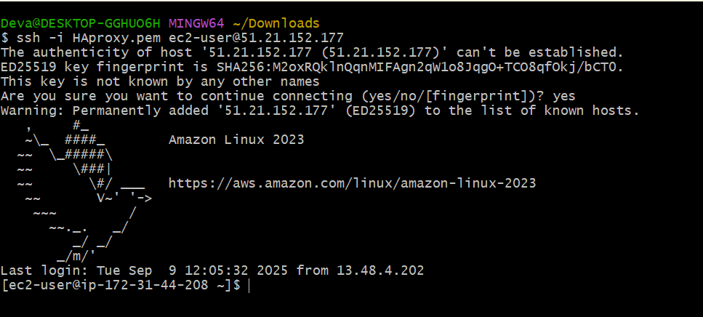

* Switch to root user - **sudo su –**

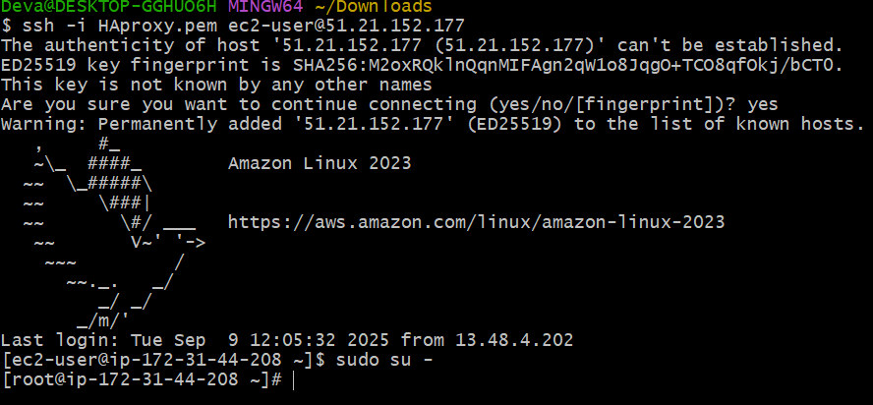

* Yum update –y

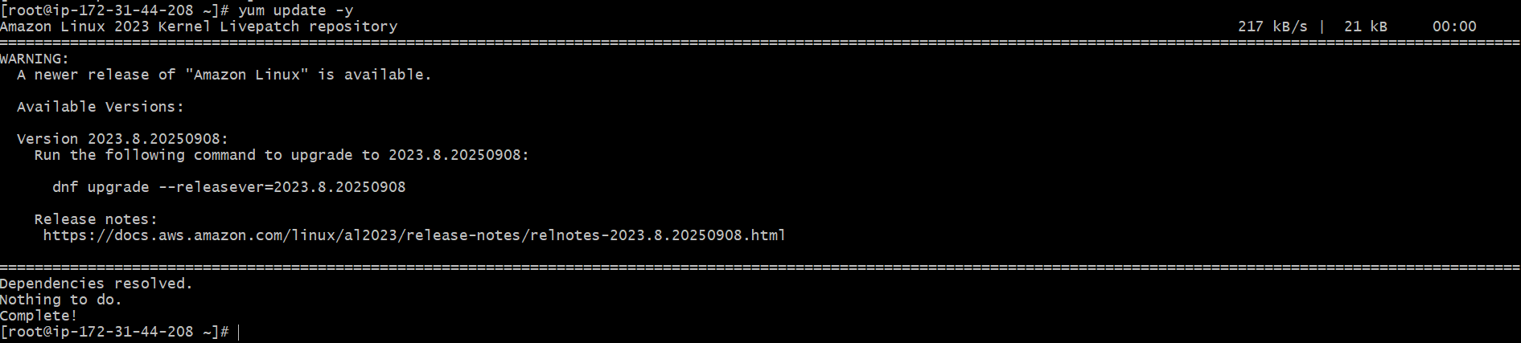

* Yum install haproxy –y

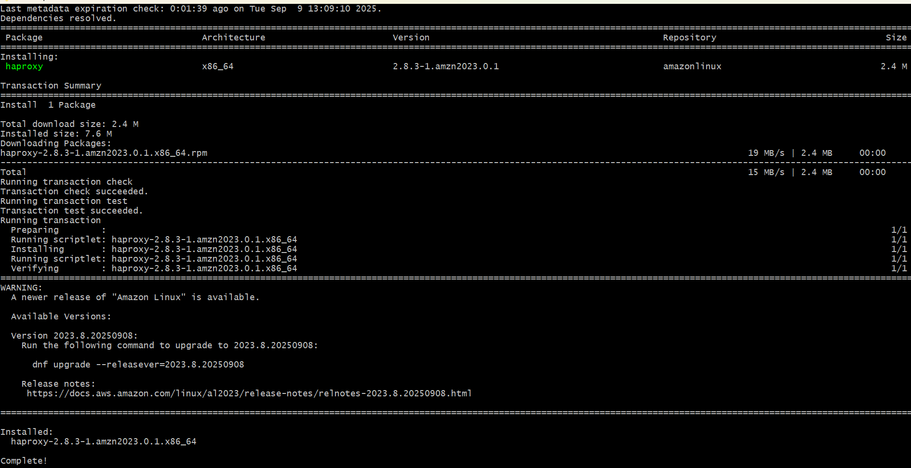

* **Vi /etc/hosts**
* Add server-1, server-2 public ip’s

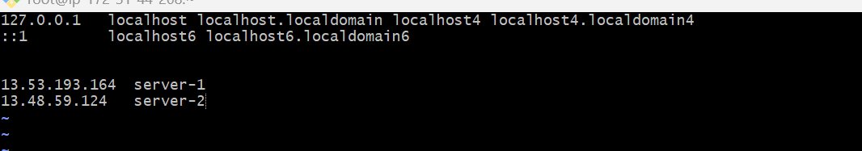

* **Cat /etc/hosts**

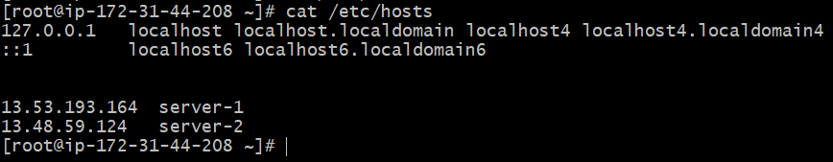

* **Vi /etc/haproxy/haproxy.cfg**
* Add server-1, server-2 public ip’s

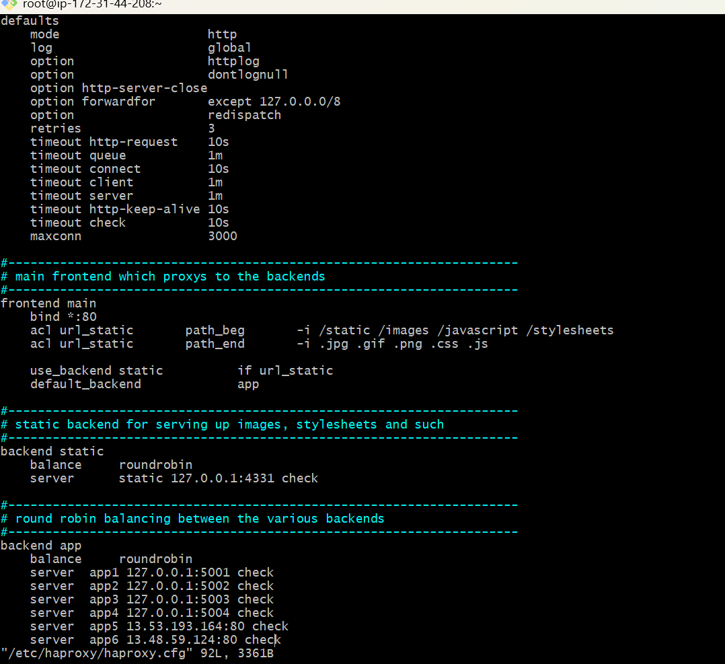

* **Systemctl enable haproxy**
* **Systemctl start haproxy**
* **Systemctl status haproxy**

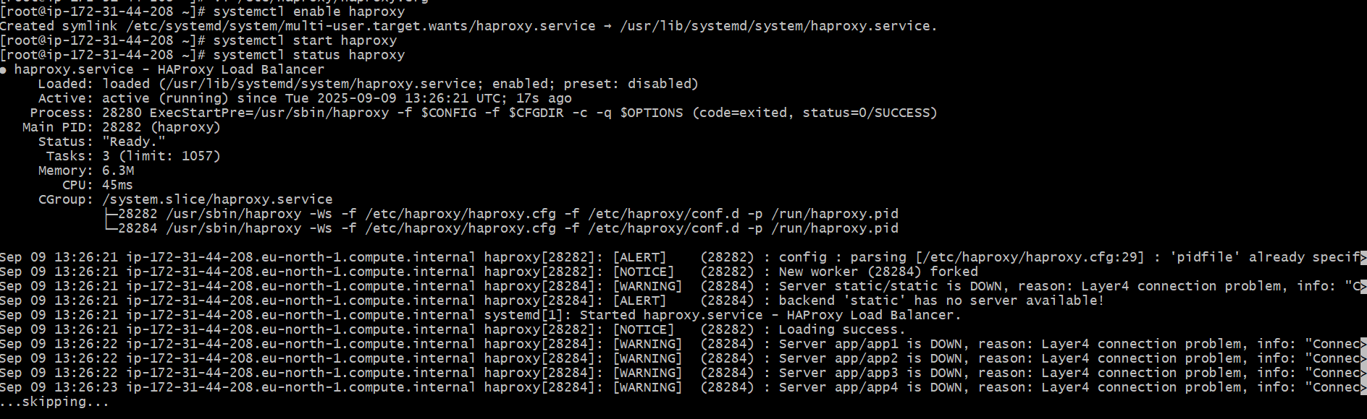

* Now check in browser with HAproxy publicip :80 it will distribute load to server-1, server-2.

